Cricket Club Pack - All Stars Cricket
All Stars Cricket is the England and Wales Cricket Board’s entry level participation programme, aimed at providing children aged five to eight with a great first experience in cricket.

Programme features:

- For all boys and girls aged five to eight
- Delivered nationwide at over 2,000 centres
- Minimum of 8 x one-hour sessions
- Emphasis on fun and being active
- Safe and fully accredited
- Mums, dads and families are encouraged to take part too
- Easy online registration
- Includes a centre pack of cricket kit
- Focus on developing childrens movement skills
  - Batting – hitting a moving ball
  - Throwing – underarm and overarm
  - Catching – small and large balls
  - Bowling – overarm
  - Running – lots of movement
  - Teamwork – fun games with friends
  - Communication – the basics of cricket
  - Spirit of Cricket – how to respect others

Every child that registers will receive a participant backpack full of goodies (see below) sent straight to their door.

Over 67,000 children took part in All Stars Cricket sessions in 2019, with 2,212 centres hosting sessions. We’re looking forward to 2020, when hopefully even more kids can enjoy ‘Big Moments’ and become All Stars!

New centres

We are excited to bring All Stars Cricket to life with your help and welcome new players and their families to your centre.

Your centre will receive full support from the England and Wales Cricket Board (ECB) when implementing All Stars Cricket, including the following:

- All Stars Cricket equipment and resources provided at zero cost to the centre
- Easy-to-use online system and tools
- National marketing campaign and marketing guide to promote your centre locally
- Online and face-to-face volunteer training
- Dedicated member of County Cricket Board staff to help implement All Stars Cricket at your centre
- Access to the All Stars Cricket helpdesk
- Receive £5 per child (based on recommended retail price of £40 per child)

Existing centres

In addition to the great benefits you received in previous years, such as free equipment and activator training, here is what was new for 2019:

- Dedicated member of staff for the duration of the programme
- Enhancements to the ClubSpark online management system to make your life easier.
- Increased marketing support with new assets to use plus a marketing and communications guide to help you promote your session locally

What do you need to become an All Stars Cricket centre?
1. A Child Welfare Officer
2. An All Stars Cricket activator at your club with a current DBS check
3. Trained first aider on site
4. Appropriate insurance that meets ECB requirements

We also recommend:

1. A commitment from the centre to provide a fun and welcoming environment for the kids
2. Male and female toilets
3. Adequate space
4. Wheelchair accessible – don’t worry if this provision isn’t currently in place. The ECB will support you to meet the requirements

Registered centres
Centres that have already registered to become a All Stars Cricket centre can access the online management system, ClubSpark, via https://ecbauth.clubspark.uk/account/signin?
The system allows clubs to manage their All Stars Cricket details, incorporating the following:

- Adding and updating contact information
- Adding activators
- Setting up bank details
- Inputting programme details – session dates and times, venues and cost

Please email allstarscricket@ecb.co.uk if you require more information around the ClubSpark system.

Centre packs
Every centre that registers for an All Stars Cricket programme and reaches 10 registrations* will receive a free pack, including:

- 1 x ASC kit bag
- 6 x bats
- 6 x sets of stumps
- 24 x plastic balls
- 24 x tennis balls
- 10 x large tennis balls
- 16 x bean bags
- 50 x cones
- 2 x pop-up banners
- 4 x teardrop banners
- 4 x 10m ropes
- 4 x parent helper vests
- Activator apparel

Returning centres

Every returning All Stars Cricket Centre will receive a free top-up pack, to complement their existing All Stars Cricket centre pack. The top up pack contains:

- 1 x holdall
- 2 x size 1 bats
- 2 x stumps
- 12 x cones
- 4 x parent helper vests
- 10 x plastic balls
- 2 x large tennis balls

Alternatively, your club can choose to receive an activator apparel top-up pack, choosing items from our new range which include leggings, crew neck t-shirts and hooded tops.
All centre packs, top-up packs and activator kit will be delivered from mid-April onwards.

*Programmes may run and kit may be allocated to programmes with fewer than 10 participants registered subject to approval from the ECB. If your club registers more than 40 participants, additional equipment will be allocated. If you have any queries, please contact the All Stars Helpdesk here or call 0800 085 7998

Your All Stars activator will oversee the programme at your Cricket club/centre
The All Stars Cricket activator is the key volunteer who will create a fun and inclusive environment for kids and parents alike. To become an activator they will need to be enthusiastic, vibrant, motivated and an individual who inspires young children and creates a fantastic all-round experience.

Although many All Stars Cricket activators have experience of cricket it is by no means essential – first and foremost, we are looking for people with fantastic personal skills.

There are potential activators all around you: Teachers, teaching assistants, enthusiastic parents, junior cricket club captains or role models at your cricket club centres or within the local community.

Once you have identified potential activators, they are provided with comprehensive face-to-face and online training and support to equip them with all the tools needed, including kit, to successfully implement your all stars fun and exciting programme.

For returning activators, it is not compulsory to attend training a second time – however a refresher session is recommended every 2 years, as the curriculum is updated based on the feedback of children, parents and fellow activators. The updated programme will be available on the icoachcricket app each April.

All activators are encouraged to join the All Stars Cricket activators Facebook group for additional support and the opportunity to speak to activators across the country. In terms of kit, they can top up their existing activator clothing or select clothing options for others supporting their role.
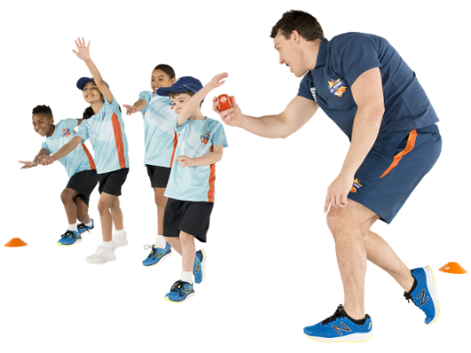

Parents and families, how can they help support All Stars Cricket at your club/centre
An important part of All Stars Cricket is that parents and siblings are encouraged to be involved too. It is a brilliant way for them to spend time as a family outdoors this summer.

All parents are asked during the registration process what activities they would be interested in helping out with during the programme. If they say yes, it is important that you contact them with further information offering them a range of support activities, so they can be involved along the way.

There are many ways that they can help out during the programme, this includes:
- Becoming,
  - A fully trained lead activator
  - a fully trained support activator
  - a parent helper, supervising fun activities for some, or all sessions
  - your centre “meet and greet” person
  - your centre registration person
  - a valuable member of the centre refreshments team
- or purely enjoy some play time with your child(ren) taking part in the sessions

Since the start of the All Stars national programme in 2017 a number of clubs have found significant benefit in running a “week 0” All Stars sessions ahead of the formal start of their programme. This can not only be used as a “bring-a-friend/family” opportunity to drive up numbers of All Stars attending but also an opportunity to hold a parents meeting and explain what is required to deliver the programme and enlist support for the many roles required to deliver a fun and exciting programme.

For an hour a week over an eight-week period, the fully trained (and vetted) activators and parent helpers will deliver game-based activities that teach basic cricket skills including catching, throwing and hitting moving balls and social skills such as teamwork and communication. Held at accredited cricket clubs, these courses are the perfect way for children to learn about cricket and make friends in a safe and, most importantly, fun environment.

Child’s participant packs
When children are registered for the first time for All Stars Cricket (year 1) they will receive a participant pack, including:

Backpack
Cricket bat
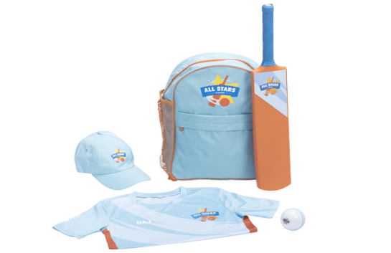
Cricket ball
Personalised shirt with name
Cap
Every child that returns to All Stars Cricket (from year 2) will receive new kit to progress their development as an All Star, it includes:

New backpack
Cricket bat
Cricket ball
New star design personalised shirt
Stumps
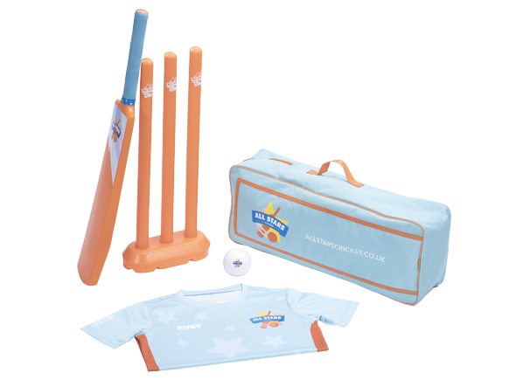

Why is All Stars Cricket good for children?
All Stars Cricket will provide children with all of the fundamental skills they need to play. Through lively, fun games, they will learn about cricket and be better prepared to take part in all sports. Over the eight-week programme, your child will learn to:

- Catch and throw a ball
- Hit a moving ball
- Bowl with a straight arm
- Play a basic game of cricket
- Work and communicate as a team
- Have lots of fun with new friends

All Stars Cricket is also fantastic for parents. For an hour a week all mums, dads siblings and families are invited to get involved and play cricket. We know this is a great way to spend time with their children and create memories that will last a lifetime.

We at Lancashire Cricket believe that cricket is a great way to spend time as a family being active, which is why All Stars Cricket encourages each and every child and parent to continue learning and playing cricket at home. This can be in their garden, in the park, on the beach, anywhere – all they need is a bat and ball.

If they have never played cricket then check out our suggestions to try with your child.

Tips:
- they don’t need to know the rules, encourage them to make up their own
- If their child is a beginner, use a big ball so they enjoy hitting and catching the ball
- Cricket can be broken down into skills like catching practice
- Throw the ball under arm and slowly
- Use our garden games videos as a guide or create your own variations
- Remember to have fun!
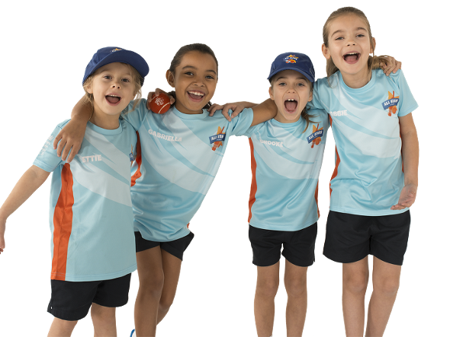

All Stars Cricket - Frequently Asked Questions
How much does the programme cost?
The minimum retail price of All Stars Cricket is £40, although some centres across England and Wales may charge an additional membership.
What does each child receive as part of the programme?
The programme cost includes 8 x 45-60 minute All Stars Cricket sessions and a child’s personalised participant pack.
How old does a child have to be to registered?
All Stars Cricket is aimed at 5-8 year olds. If a child is younger than 5, we still welcome them to be involved but ask that a parent or guardian gets involved as a parent helper and supports their involvement in the programme.
When will a child’s kit be delivered?
Kit will take around 10 working days to be delivered, although could take a little longer if registration is close to the official All Stars start date.
What can children and parents expect at an All Stars Cricket session?
All Stars Cricket is an action-packed, fun programme of game-based activities that will help develop a child’s fundamental movement skills for an active life. Throughout the eight weeks, children will be learning lots of new skills, making friends and most importantly having an exciting summer!
How can parents get involved?
An important part of All Stars Cricket is that parents should be encouraged to be involved too. It is a brilliant way for them to spend time with their child outdoors this summer. All parents are asked during the registration process if they would be interested in helping out during the programme. If they say yes, it is important that you contact them with further information offering them a range of support activities so they can be involved along the way.
Is the programme safe?
Yes, the All Stars Cricket programme is an initiative designed by the England and Wales Cricket Board (ECB). The ECB requires all of the centres to undergo safeguarding, risk and insurance assessments before they are accredited. Alongside this, all of our All Stars Cricket activators have received training and are fully checked through the Disclosure and Barring Service (DBS).

